Deploying honeypot with pentbox

First download the pentbox package

wget http://downloads.sourceforge.net/project/pentbox18realised/pentbox-1.8.tar.gz

tar xvfz pentbox-1.8.tar.gz

cd to pentbox-1.8

running the pentbox ruby script:-

./pentbox.rb

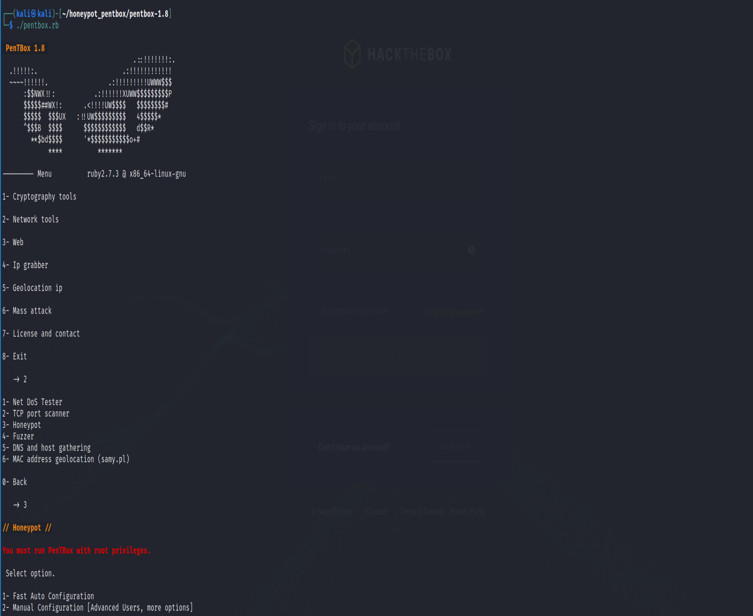

If select fast auto configuration it will deploy honeypot of port 80

When trying to connect with web browser to the kali machine ip we will ger access denied error



At the honeypot terminal you can see the attempt tracked and detected

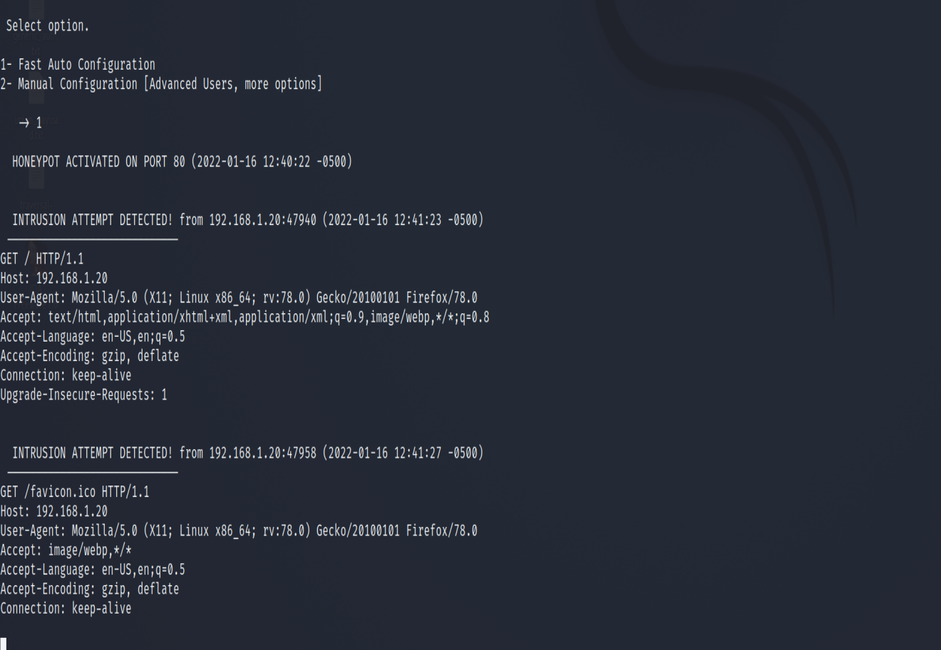

We can set manual configuration on a port we like

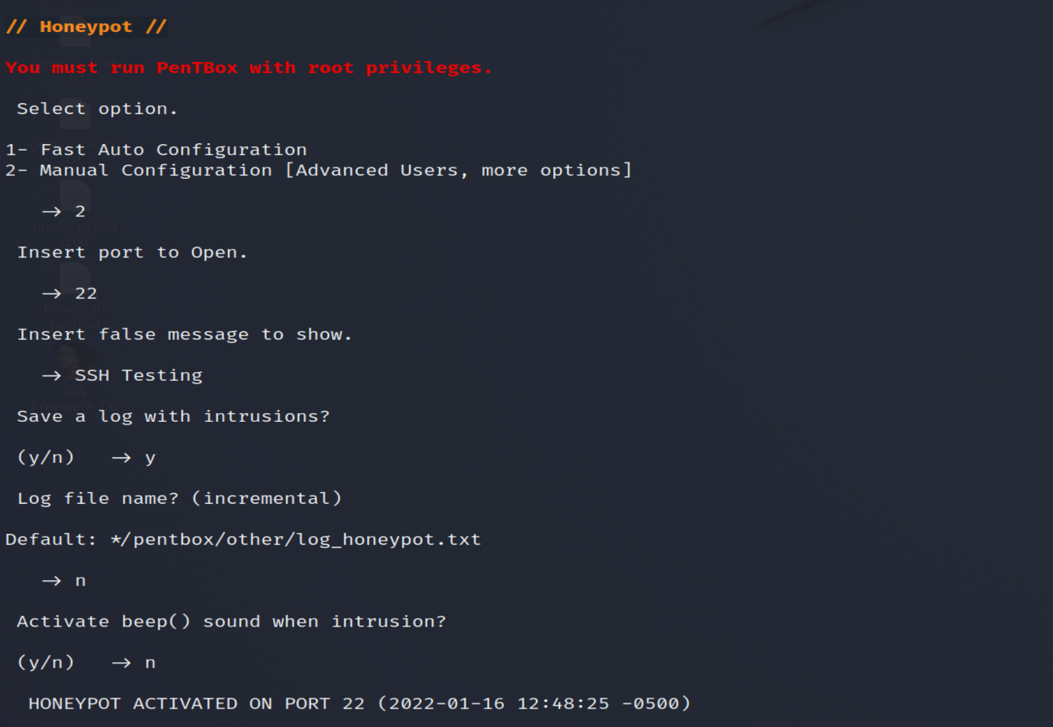

Testing it

